

GRADUATION THESIS DOCUMENT
EMPLOYEE CASH ADVANCE PROCESS
Supervisors:
FPT Software
Trương Thị Hoài Vi - Technical Consultant
Lê Thị Thu Hiền - Functional Consultant
FPT University
Võ Thị Thanh Vân - Technical Instructor
Nguyễn Hoàng Linh - Functional Instructor
Group member:
Trần Bình Minh - SE17051
Lê Minh Nhật - SE171573
Phạm Hoàng Nguyên - SE161197
Trần Phú Nguyên - SS150122
Nguyễn Thị Khang - SE150828
-Ho Chi Minh city, 5/2025-

Table of Contents
I. Record of Changes 4
II. Implement 5
1. Process used in guide document 5
2. Installation Guides 6
2.1. System Requirements 6
2.2. Installation Instruction 7
3. User Manual 8
3.1. Overview 8
3.2. Customer Master Data Preparation 8
3.2.1. Context 8
3.2.2 Details Implement 9
3.3. Check Employee Information 14
3.3.1. Context 14
3.3.2. Details Implement 15
3.4. Create employee advance request 16
3.4.1. Context 16
3.4.2. Details Implement 17
3.5. Approve or Reject the advance request by the Manager 21
3.5.1. Context 21
3.5.2. Details Implement 21
3.5.2.1. Manager approves the advance request 24
3.5.2.2. Manager rejects the advance request 25
3.6. Approve or Reject the advance request by the Director 28
3.6.1. Context 28
3.6.2. Details Implement 28
3.6.2.1. Director approves the advance request 31
3.6.2.2. Director rejects the advance request 33
3.7. Post Vendor Down Payment 35
3.7.1. Context 35
3.7.2. Details Implement 36
Post Vendor Down Payment 36
3.8. Submit and record expense documents 38
3.8.1. Context 38
3.8.2. Details Implement 39
3.9. Approve parked documents 45
3.9.1. Context 45
3.9.2. Details Implement 45
3.9.2.1. Accountant approves the advance request 48
3.9.2.2. Accountant rejects the advance request 49
3.10. Advance settlements 51
3.10.1. Context 51
3.10.2. Details Implement 51
3.11. Download form the advance settlement 54
3.11.1. Context 54
3.11.2. Details Implement 55
3.12. Post Incoming Payments / Post Outgoing Payments 56
3.12.1. Context 56
3.12.2. Details Implement 57

I. Record of Changes
Date | A*, M, D | In charge | Change Description
A* - Added ; M - Modified ; D - Deleted

II. Implement

1. Process used in guide document
No | Definition | Note
1 | Customer Master Data Preparation
2 | Check Employee Information | ZFIEMP
3 | Create employee advance request | ZFIECAP
4 | Approve or Reject the advance request by the Manager | ZFIECAP
5 | Approve or Reject the advance request by the Director | ZFIECAP
6 | Post Vendor Down Payment | F-48
7 | Submit and record expense documents | ZFIECAP
8 | Approve parked documents | ZFIECAP
9 | Advance settlements | ZFIECAP
10 | Download form advance settlement | ZFIECAP
11 | Post Incoming Payments / Post Outgoing Payments | ZFIECAP & F-28 / F-53

2. Installation Guides
The Installation Guide section gives both basic and detailed instructions on how to set up contexts in the SAP system. It explains how to configure the system's overall structure, including the setup of environments and the clients within each one. By following this guide, users can build a full SAP system that matches the customer's company structure, helping to improve work efficiency and productivity.

2.1. System Requirements
The process steps will be to set up the following three systems: development (DEV), quality assurance (QAS) and production (PRD).
Development System (DEV): includes Custom Client (CUST). This is the environment used to make changes to Custom Data (configuration settings) and Warehouse Objects (such as programs and tables). The changes made here will be packaged into Change Requests. (Change Requests).
Quality assurance (QAS): The development system (DEV) includes Custom Client (CUST). This is the environment used to make changes to Custom Data (configuration settings) and Warehouse Objects (such as programs and tables). The changes made here will be packaged into Change Requests. (Change Requests).
Production (PRD): The development system (DEV) includes Custom Client (CUST). This is the environment used to make changes to Custom Data (configuration settings) and Warehouse Objects (such as programs and tables). The changes made here will be packaged into Change Requests. (Change Requests).
The change development process begins with implementing all changes in the DEV system. (CUST). Then, the changes are released and deployed to the QAS system for testing. In QAS, thorough tests are conducted to ensure that the changes work as expected. Finally, only after the changes pass the tests successfully, are they deployed to the PRD system for actual use in the production environment.

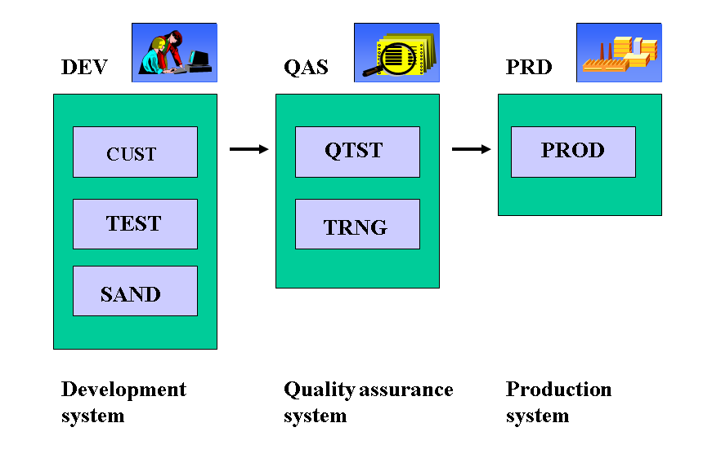

2.2. Installation Instruction
The steps to apply SAP ERP for accounts receivable will be configured and deployed on cloud storage. StellarSites Studios, in the case of SFPT Mobile, will use SAP GUI web. Here are instructions for getting started and progressing on the SAP GUI web:
1. Access the link:
https://s40lp1.ucc.cit.tum.de:8100/sap/bc/gui/sap/its/webgui
2. Login by account SAP:
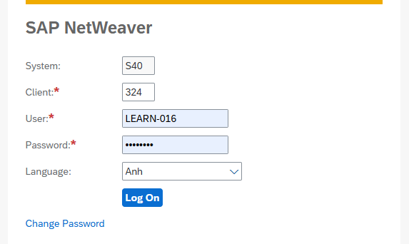

3. User Manual

3.1. Overview
The instructions below help users use the system easily, following the process provided by EY Vietnam to manage and track customer receivables. This process also ensures that customer invoices are issued according to the regulations of the Ministry of Finance of Vietnam.

3.2. Customer Master Data Preparation

3.2.1. Context
The customer master data preparation process in SAP helps make sure all customer information is correct, consistent, and available across the whole SAP system. This information is very important for tasks like processing orders, handling payments, and making reports. The process includes gathering customer details and entering them into SAP so that it’s easier to manage what customers owe for future orders. For step-by-step instructions on which app to use and how to create new customer records, please check the related document.

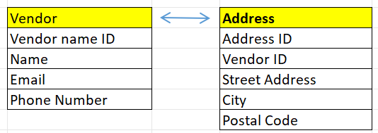

3.2.2 Details Implement
Transaction code
T-code | Description
XK01 | Create a Vendor
XK02 | Display a Vendor
XK03 | Change a Vendor

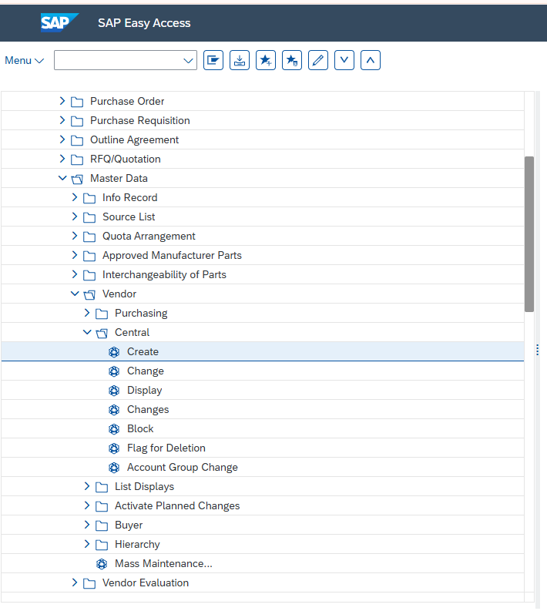

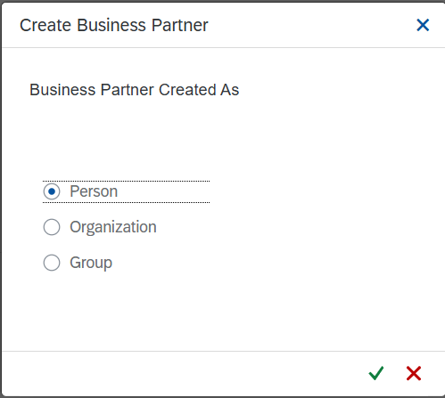
Choose the desired client segments and

Field Name | Description
Person | Specific individual
Organization | Organization or company
Group | Customer group, affiliated organization

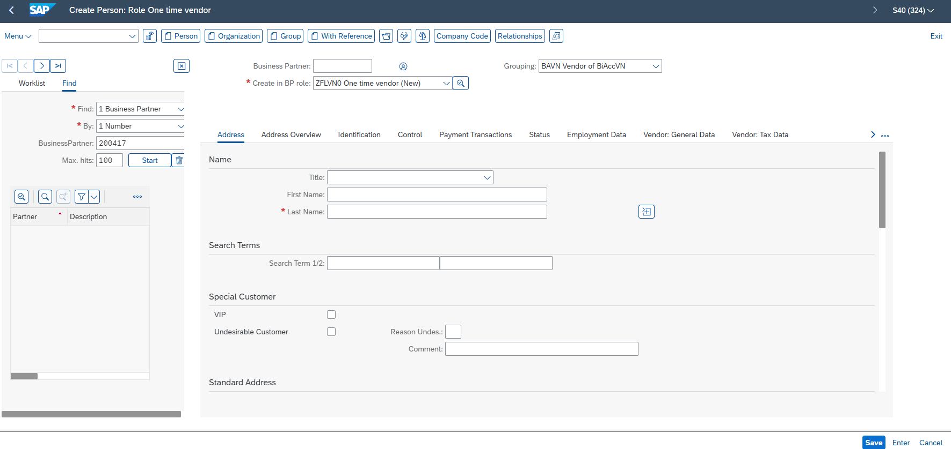

In the Overview screen: Input the following information
No. | Field name | R/O/D | Description and Example
1 | Business Partner | R | Unique BP ID. Example: 200426
2 | Create in BP role | R | Role type: 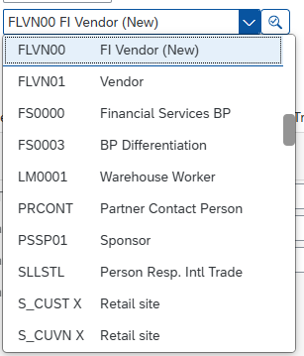
3 | Title | R | Formal title  For Women : 0001- Mis.  For Man: 0002 - Mr.
4 | First Name | R | Given name - Nga
5 | Last Name | R | Family name - Thanh
6 | Correspondence lang. | R | Language preference - EN
7 | Search Term 1/2 | R | Search keyword - Thanh Nga
8 | Postal Code / City | R | ZIP and city - 700000/Ho Chi Minh
9 | Country/ Region | R | Country code - VN/HCM
10 | Telephone | O | Contact number - 0879381254


Click Enter to confirm the information of the customer. After that, Click Button jk to assign a Customer to the company.
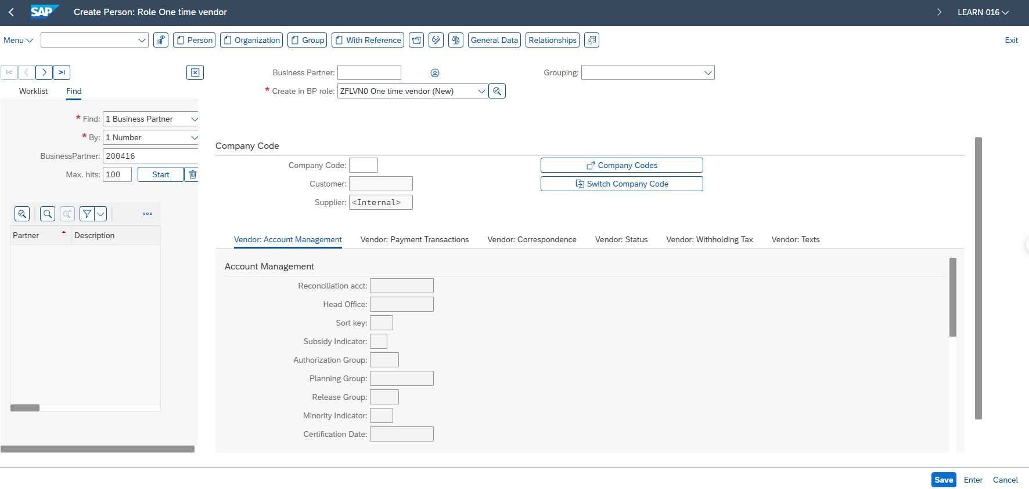

Field Name | Description
Company Code | Enter company code - GR06

Click Enter
In Fill “Reconciliation acct”
No. | Field name | R/O/D | Description and Example
1 | Reconciliation acct | R | the GL account used for customer reconciliation -1410000000

In , tick the box, to Check 2 duplicate invoices

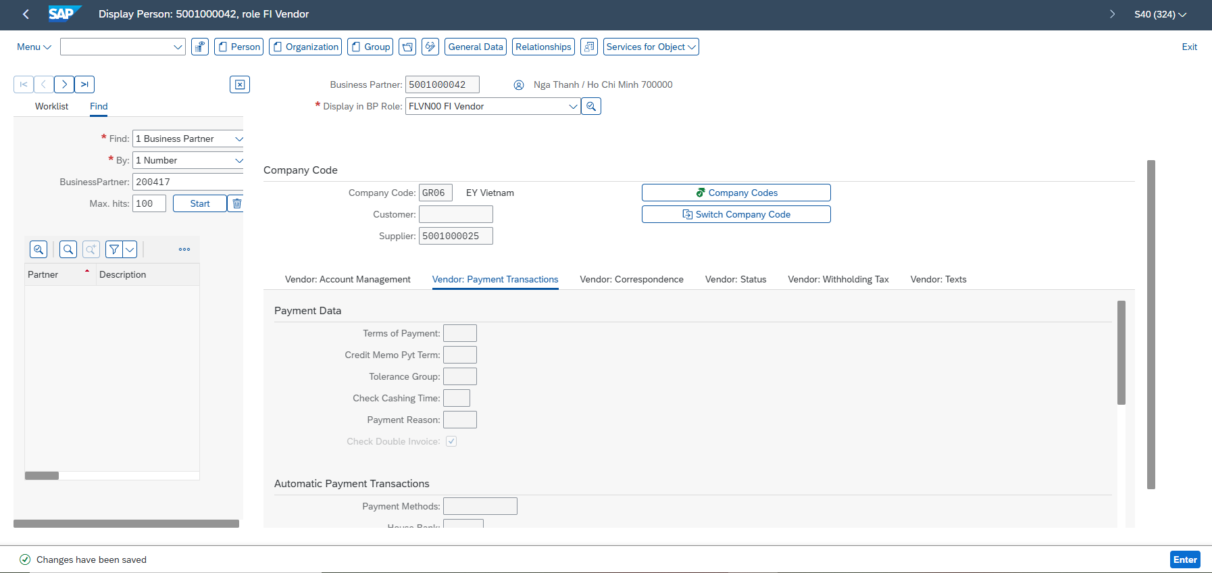

3.3. Check Employee Information

3.3.1. Context
The ZFIEMP transaction code in SAP FI is used to view detailed employee information related to financial processes. It allows users to filter by company code, employee ID, department, and position, making it easier to find specific employees or groups. The results are displayed in ALV format, which supports sorting, filtering, and exporting data. Key details such as the employee's full name, ID, phone number, and email are shown, along with job-related information like department and position. Additionally, financial data, including advance limits, balances, and available amounts, can be viewed. This tool helps both Finance and HR teams manage employee records efficiently. ZFIEMP ensures transparency and accuracy in handling employee financial data in one place.

3.3.2. Details Implement
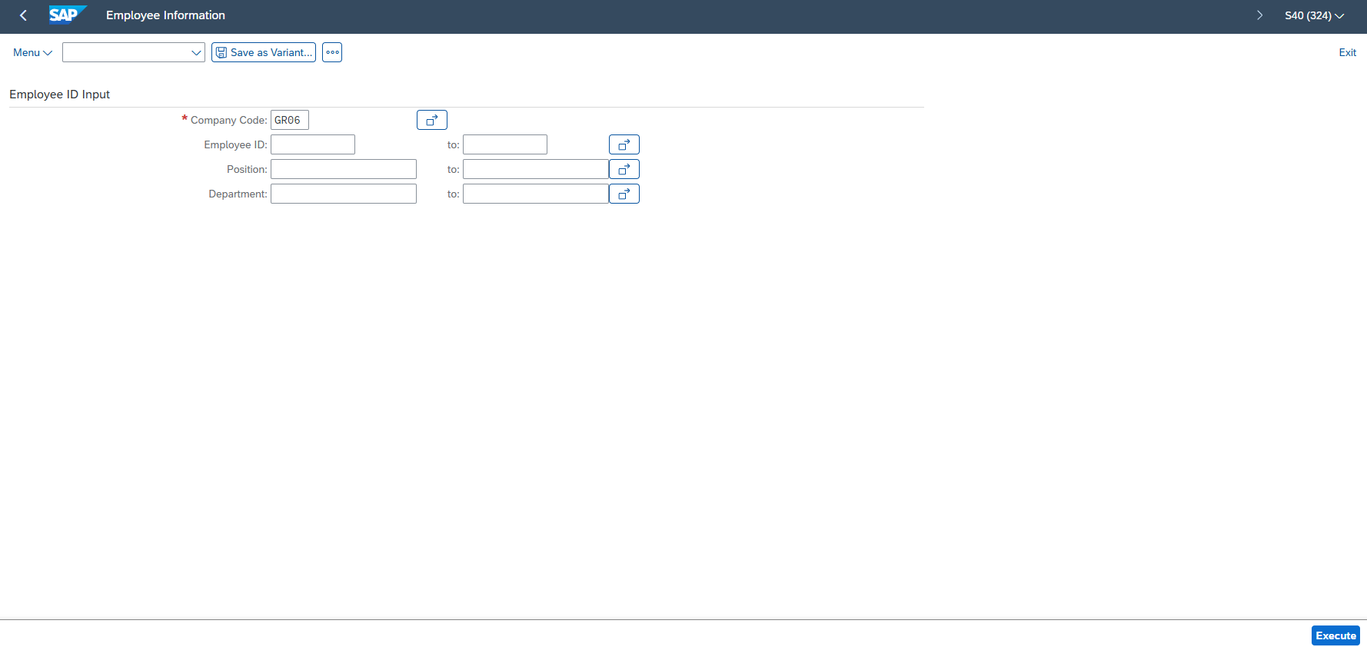

T-code | Description
ZFIEMP | Employee Information

No. | Field name | R/O/D | Description and Example
1 | Company Code | R | To specify the organization or legal entity the employee belongs to. Ex: GR06
2 | Employee ID | O | To look up a specific individual.
3 | Position | O | To search for employees working under a particular business unit.
4 | Department | O | To filter by job title or role within the company. the transaction.

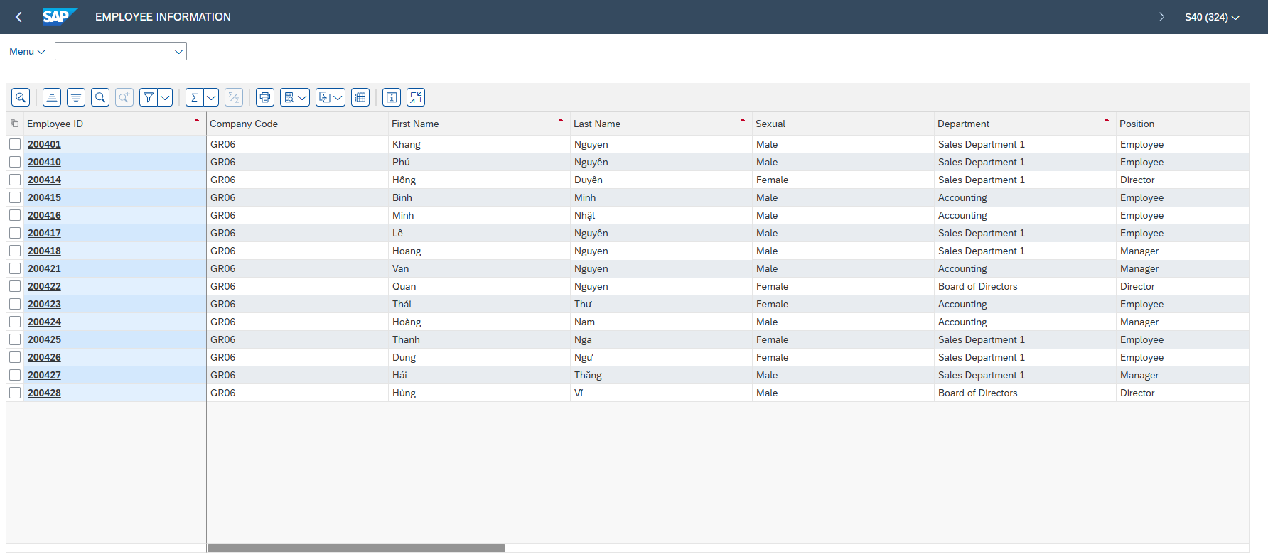

3.4. Create employee advance request

3.4.1. Context
To create an employee advance request in SAP, use the ZFIECAP transaction code. Each employee is assigned a specific budget limit, and the system will not allow the creation of requests that exceed this limit. If the requested amount is within the allowed budget, the user can proceed with the request. Required input fields include the employee’s vendor account, requested amount, document and posting dates, reason for the advance, and company code. This process helps ensure controlled and budget-compliant advance management.

3.4.2. Details Implement
Transaction code
T-code | Description
ZFIECAP | Display information of advance request

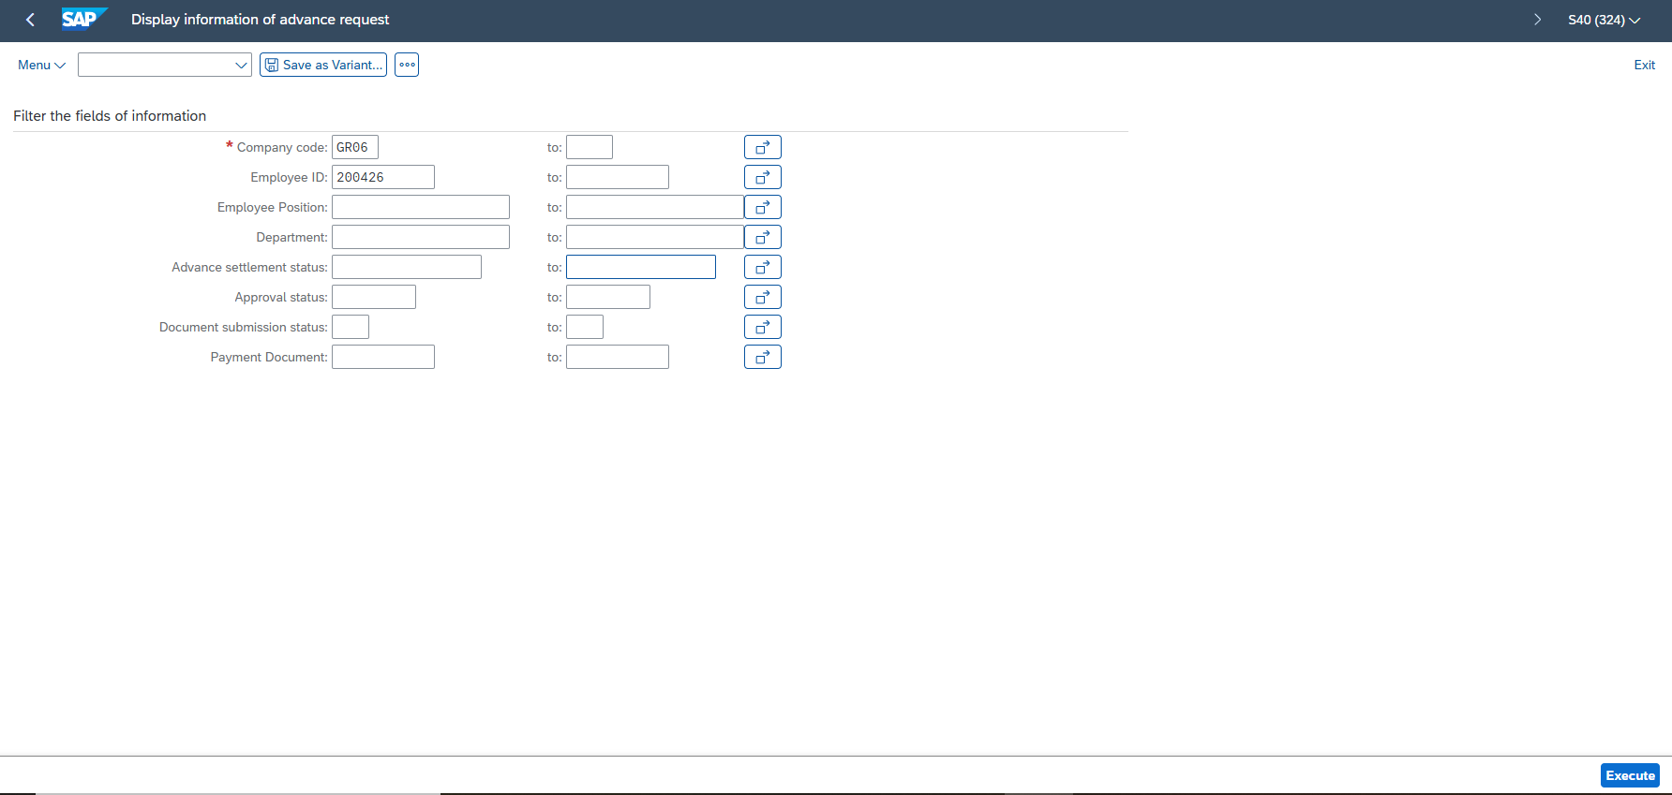

No. | Field name | R/O/D | Description and Example
1 | Company Code | R | Identifies the legal entity or business unit the employee belongs to.
2 | Employee ID | O | Uniquely identifies the employee submitting the advance request.
3 | Employee Position | O | Shows the employee's current role within the organization.
4 | Department | O | Indicates the department the employee is assigned to, useful for internal tracking.
5 | Advance Settlement Status | O | Indicates whether the requested advance has been cleared or open.
6 | Approval Status | O | Shows whether the request has been approved by the authorized personnel.
7 | Document Submission Status | O | Reflects whether the employee has submitted all required supporting documents.
8 | Payment Due Date | O | Specifies when the advance payment is scheduled to be processed.

After entering the required search parameters, click Execute to view the information of the advance requests.
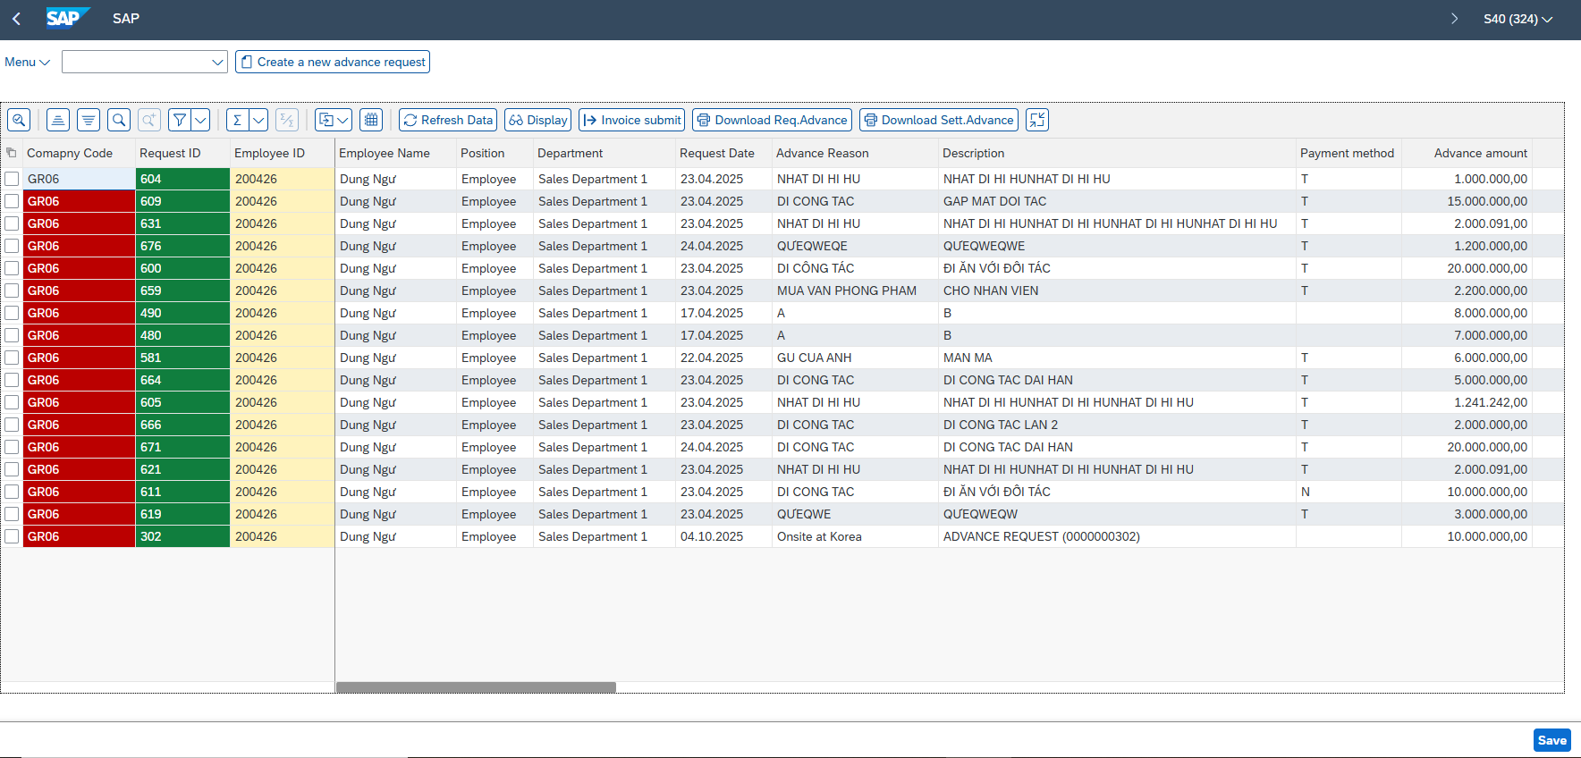
Click  to create a new advance request
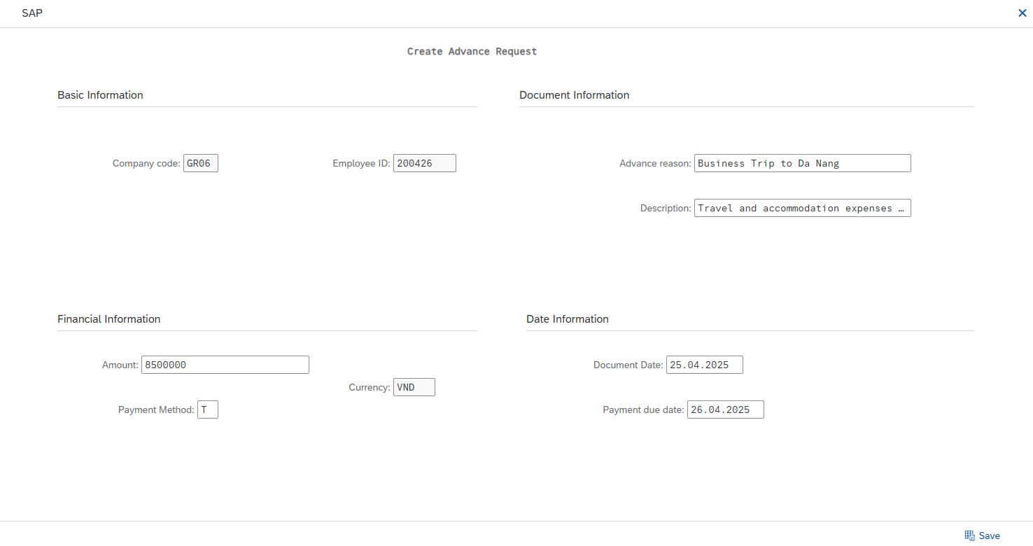

No. | Field name | R/O/D | Description and Example
1 | Company Code | R | GR06
2 | Employee ID | R | 200426
3 | Advance reason | R | Business Trip to Da Nang
4 | Description | R | Travel and accommodation expenses for client visit
5 | Amount | R | 8500000
6 | Currency | R | VND
7 | Payment Method | R | T
8 | Document Date | R | 25.04.2025
9 | Payment due date | R | 26.04.2025

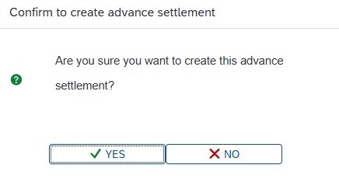
Press ,
Press YES
You have successfully created an advance request 686. The information has been updated in the advance request list.

3.5. Approve or Reject the advance request by the Manager

3.5.1. Context
In this step, the manager plays a key role in reviewing the employee's advance request. Based on the submitted information, supporting documents, and alignment with company policies, the manager must decide whether to approve or reject the request. A detailed review is essential to ensure the request is valid, reasonable, and within the employee’s budget limits. Each manager is responsible for handling the requests submitted by employees within their own department, ensuring oversight and relevance to the team’s operational needs. If approved, the process will move forward to the next stage. If rejected, the request is returned to the employee with a clear explanation so that any necessary corrections or clarifications can be made. This step ensures accountability and proper financial control within the organization.

3.5.2. Details Implement
The manager will use the Assigned Account to approve or reject the advance request.
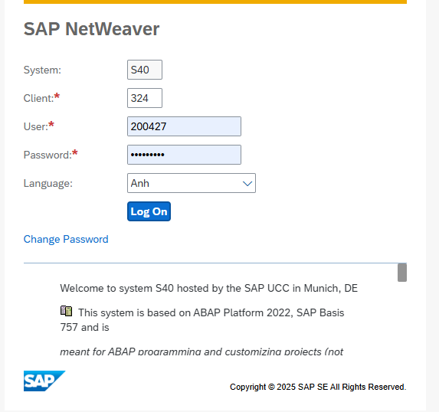

Transaction code
T-code | Description
ZFIECAP | Display information of advance request

Enter T- code,
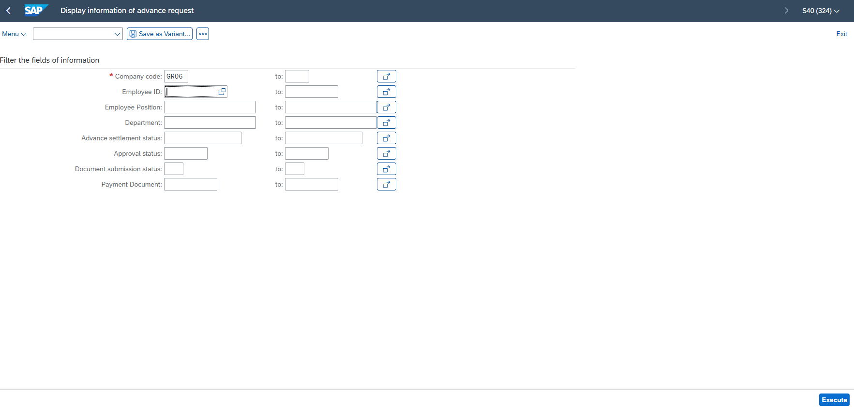
Press Execute
Then click on symbol ”Find”. To search for the advance request created in the previous step.
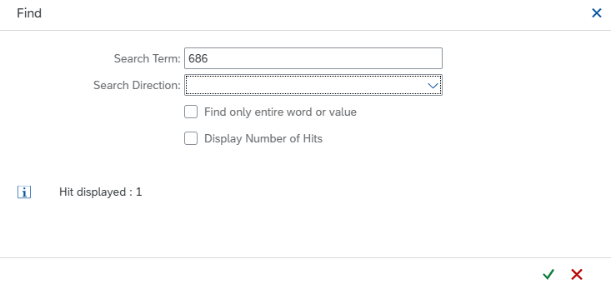
Press

3.5.2.1. Manager approves the advance request

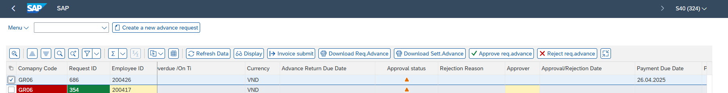
Select of the row with the request ID that needs approval, then click to approve the 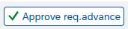advance request.

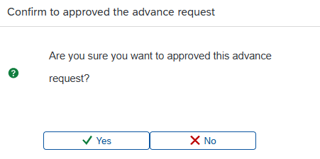
A confirmation message will appear. Select 
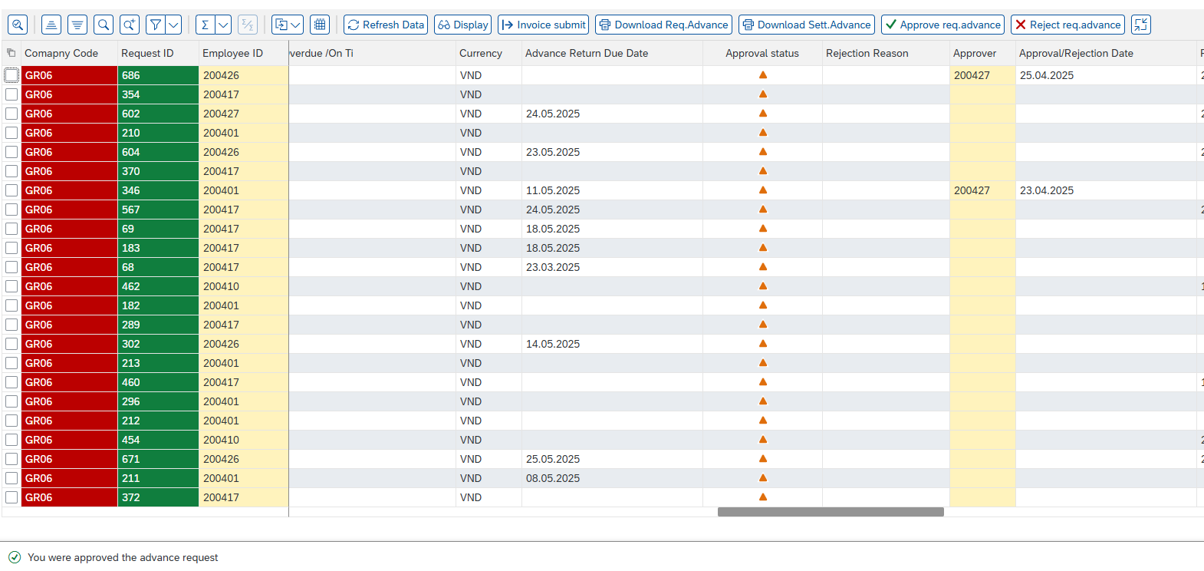
A message “You were approved the advance request” will appear, indicating that the Manager has approved the advance request. Go to the next step after the advance request is approved.

3.5.2.2. Manager rejects the advance request


Select of the row with the request ID that needs rejection, then click to reject the advance request.

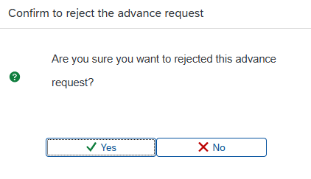
A confirmation message will appear. Select 

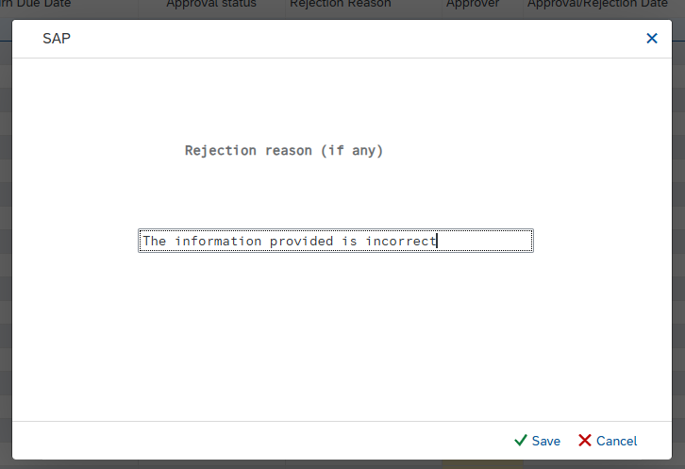

No. | Field name | R/O/D | Description and Example
1 | Rejection Reason | R | The information provided is incorrect

Fill in the rejection reason and click .

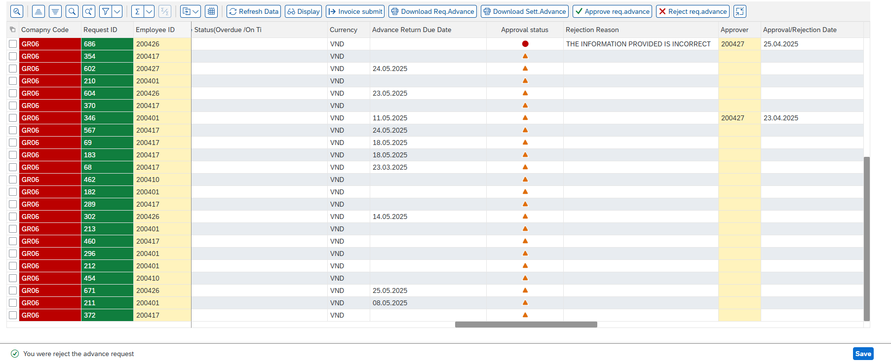

A message “You were a reject the advance request” will appear, indicating that the Manager has rejected the advance request. Return to the employee for editing and re-creating the advance request.

3.6. Approve or Reject the advance request by the Director

3.6.1. Context
At this step, the advance request is sent to the Director for final approval. The Director is responsible for managing all employee advance requests within the company, including reviewing request details, ensuring compliance with internal policies, and making the final decision. Based on the provided information and justification, the Director can either approve or reject the request. All pending requests are displayed in the Director's approval queue for centralized tracking and timely processing. Once the action is taken, the employee will be notified accordingly.

3.6.2. Details Implement
The director will use the Assigned Account to approve or reject the advance request.
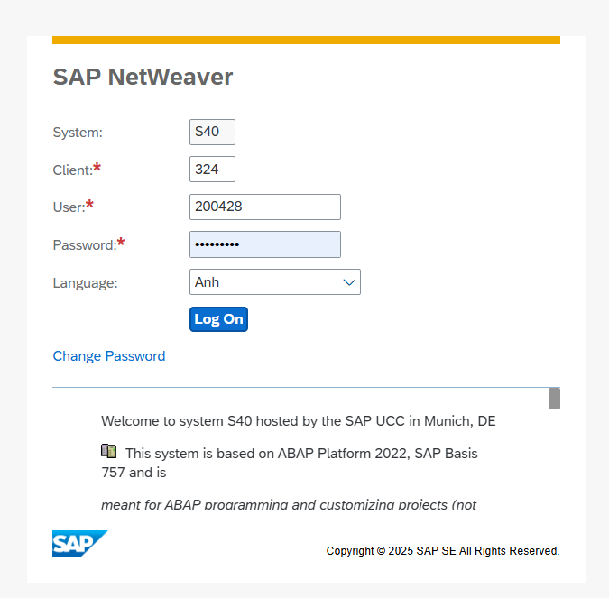

Transaction Code
T-code | Description
ZFIECAP | Display information of advance request

Enter T-Code,
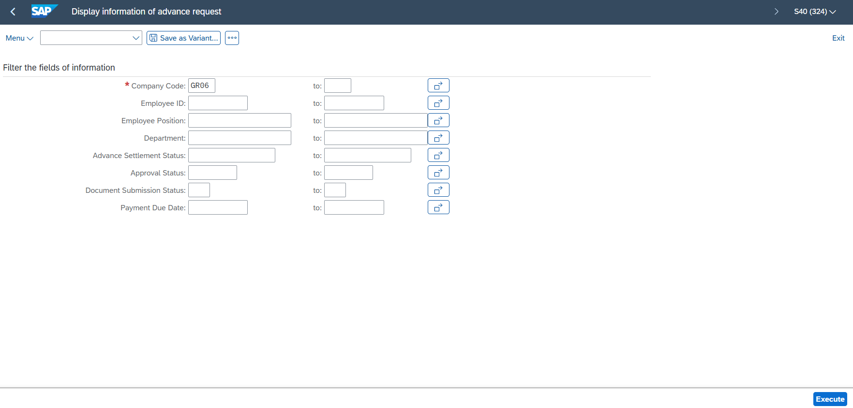

Press Execute.
Then click on symbol  'Find', to search for advance requests that have been approved by the Director.
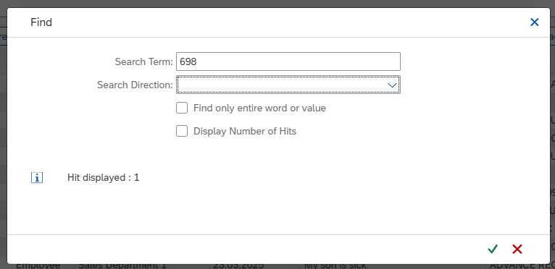
Press

3.6.2.1. Director approves the advance request
Select of the row with the request ID that needs approval, then click to approve the advance request.

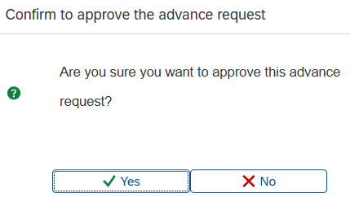
A confirmation message will appear. Select 

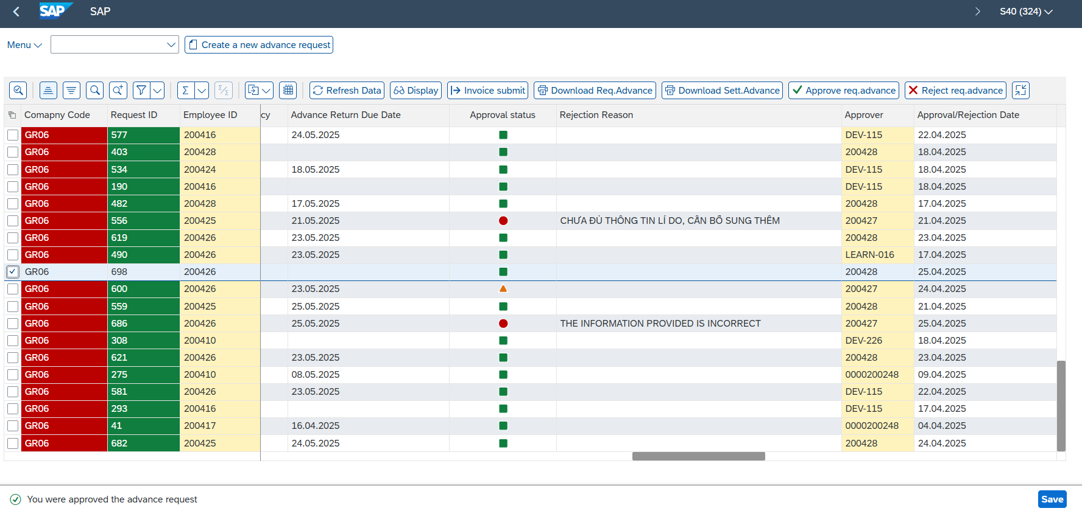
A message “You were approved the advance request” will appear, indicating that the Director has approved the advance request. After the approval from the Director, the accounting department can make the payment of the advance amount to the requestor.

3.6.2.2. Director rejects the advance request
Select of the row with the request ID that needs rejection, then click to reject the advance request.

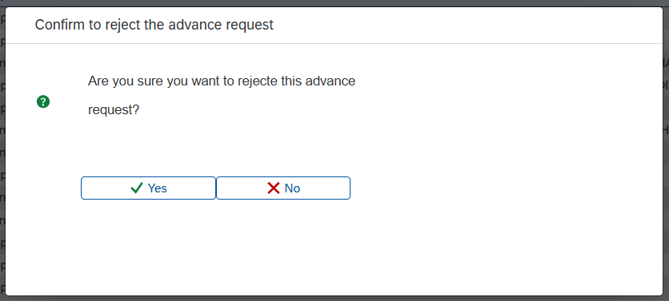
A confirmation message will appear. Select 



No. | Field name | R/O/D | Description and Example
1 | Rejection Reason | R | The information provided is incorrect

Fill in the rejection reason and click .


A message “You were rejected the advance request” will appear, indicating that the Manager has rejected the advance request. Return to the employee for editing and re-creating the advance request.

3.7. Post Vendor Down Payment

3.7.1. Context
When processing the advance payment for employees, after the Director has approved the request, the accounting department uses transaction F-48 in SAP to record the advance given to the requestor. Before making the payment, the accounting team must Post Vendor Down Payment to recognize the advance payment made to the employee. This process involves transferring funds from the company's account to the recipient's account, ensuring that all relevant details such as the amount, recipient, and account entries are accurately reflected. The accounting team will enter to necessary information in transaction F-48, including the recipient's account number, the advance amount, and other relevant details to complete the payment.

3.7.2. Details Implement
Transaction Code
T-code | Description
F-48 | Post Vendor Down Payment

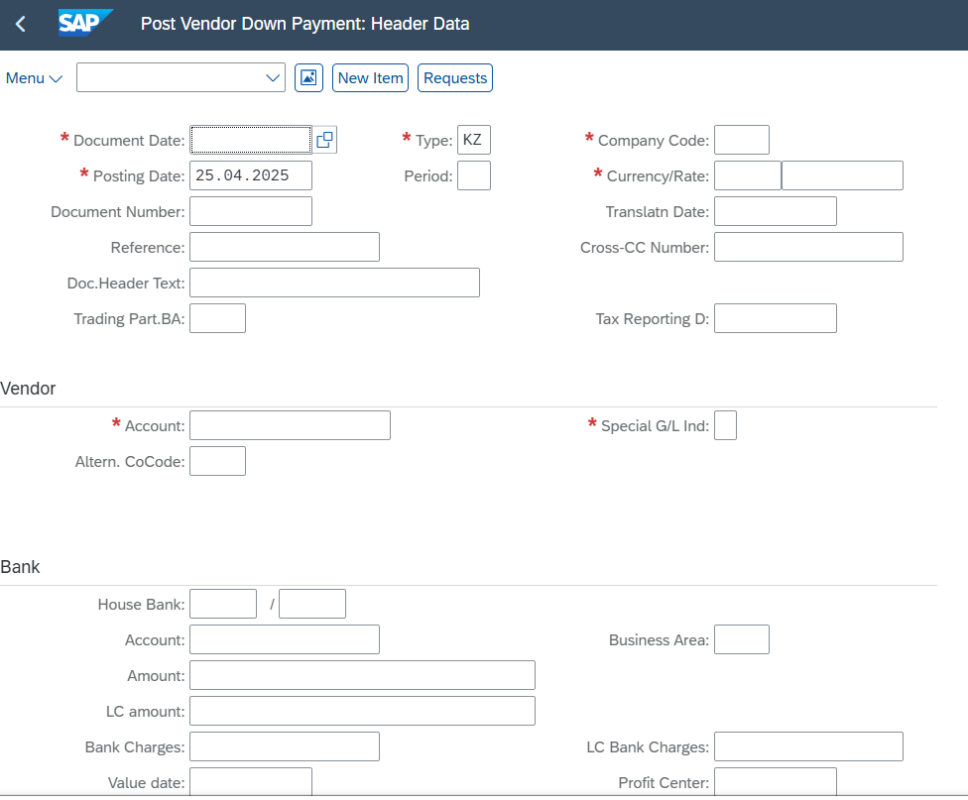

No. | Field name | R/O/D | Description and Example
1 | Document Date | R | 25.04.2025
2 | Posting Date | R | 25.04.2025
3 | Type | R | KZ
4 | Period | R | 4
5 | Company Code | R | GR06
6 | Currency/Rate | R | VND/ “ “
Vendor
1 | Account | R | 200426
2 | Special G/L Ind | R | a
Bank
1 | House Bank | R | VCB
2 | Account | R | 1120000000
3 | Amount | R | 8500000
4 | Text | O | Advance payment of 8.500.000 to 200426

Press , to select one of the advance request forms that have been submitted.

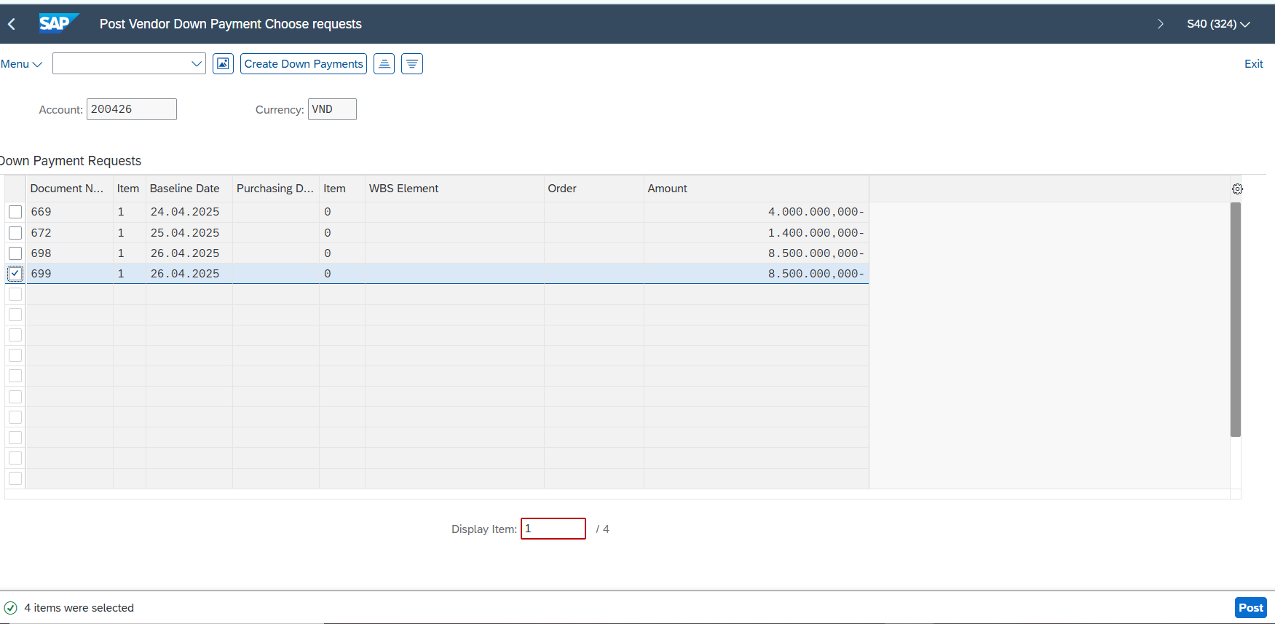
Tick the box , to select the advance request form to be paid.

Press . And a notification will appear

The request has been successfully paid.

3.8. Submit and record expense documents

3.8.1. Context
After spending the advance amount, the employee is responsible for submitting supporting documents related to the expenses, such as receipts, invoices, or travel reports. These documents provide evidence of how the advance was used and must be submitted within the required timeframe. Once submitted, the documents will be reviewed and recorded in the system for reconciliation with the advance payment. This step ensures accountability, transparency, and proper financial tracking.

Accounting in SAP:

Debit Selling Expenses (GL 641*)
Debit Other Operating Expenses of the Company (GL 642*)
Credit Employee Advances (GL 141*)

3.8.2. Details Implement
Transaction Code
T-code | Description
ZFIECAP | Display information of advance request

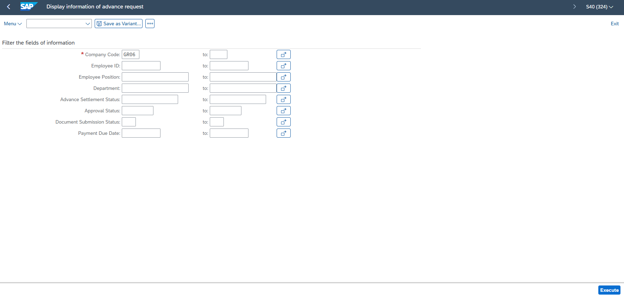
Press ,

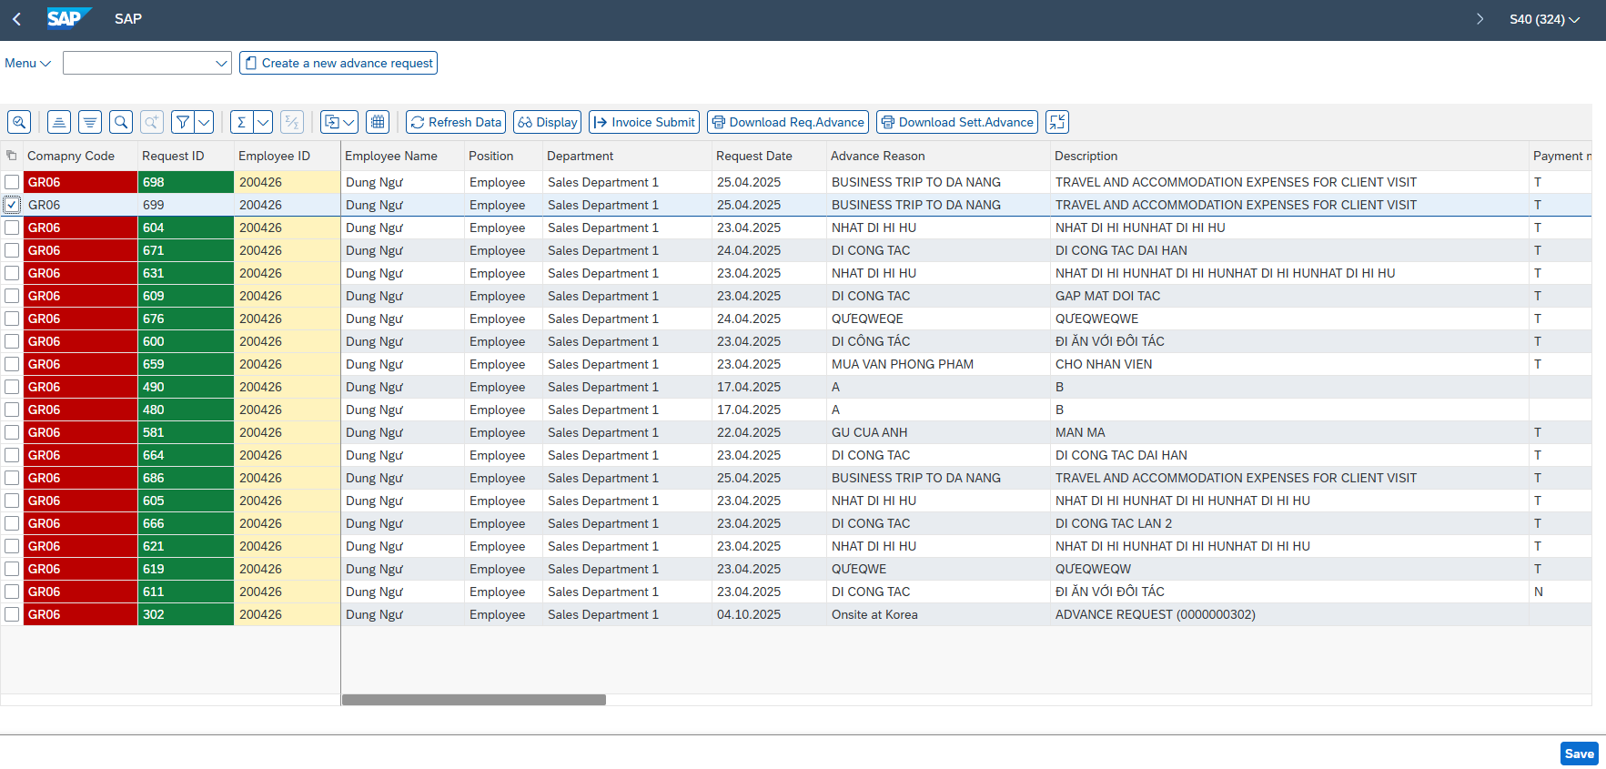
Select of the row with the request ID that needs approval, then click to park an invoice document for review or approval before posting.

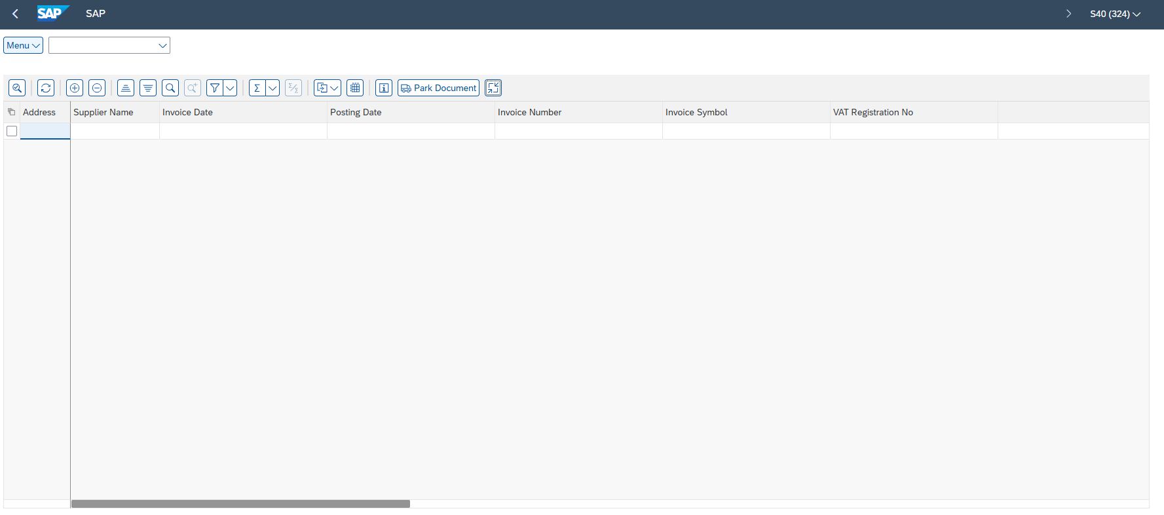
Press  “Insert Row” to add a new line item for entering invoice details.

Fill information
No. | Field name | R/O/D | Description and Example
1 | Address | R | 123 Nguyen Trai St, District 1, HCMC
2 | Supplier Name | R | ABC Trading Co., Ltd.
3 | Invoice Date | R | 25.04.2025
4 | Posting date | R | 25.04.2025
5 | Invoice Number | R | INV-20250410-001
6 | Invoice Symbol | R | AB/25E
7 | VAT Registration No | R | 0312345678
8 | Amount | R | 7500000
9 | Currency | R | VND
10 | Tax Code | R | V1
11 | Tax % | D | 10%
12 | Tax Amount | D | 750.000
13 | Total Amount | D | 8.250.000
14 | Cost Type | R | 6420000001
15 | Cost Name | D | Chi phí quản lý doanh nghiệp
16 | Text | R | Business Trip to Da Nang Invoice

Tick to select the invoice to be parked.
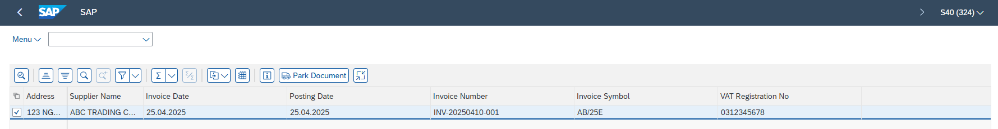

Then press ,

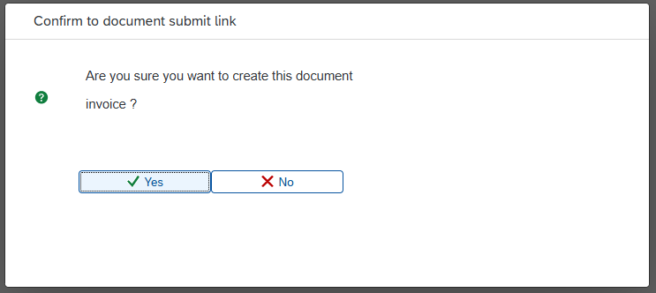
Press ,

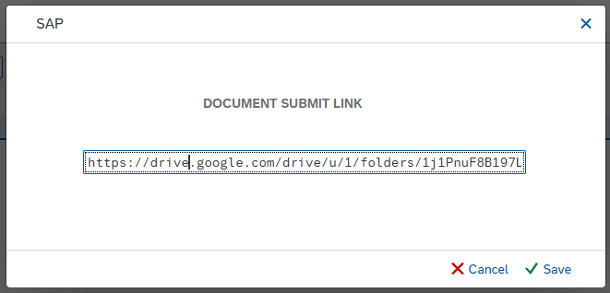

No. | Field name | R/O/D | Description and Example
1 | DOCUMENT SUBMIT LINK | R | https://drive.google.com/drive/u/1/folders/1j1PnuF8B197LZw8IijN2tW_R7Vx302f9
Press ,
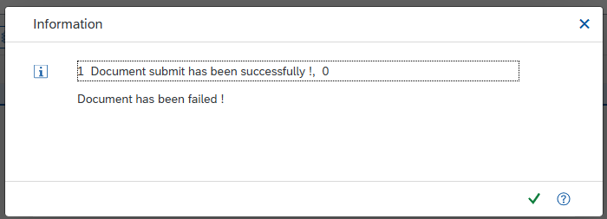
The invoice has been successfully submitted.

3.9. Approve parked documents

3.9.1. Context
In the advance request process using the ZFIECAP interface, the accountant acts as the authorized approver to review and approve parked documents. The approval step includes verifying account details, amount, and the purpose of the request to ensure accuracy and compliance. If any discrepancies or missing information are find, the accountant can use the “Reject” button to return the document for correction. Only when all information is complete and valid, the accountant will proceed with approval, allowing the request to move forward in the workflow.

3.9.2. Details Implement
Use an authorized accountant account to approve or reject the parked invoice. Ex: User 200423
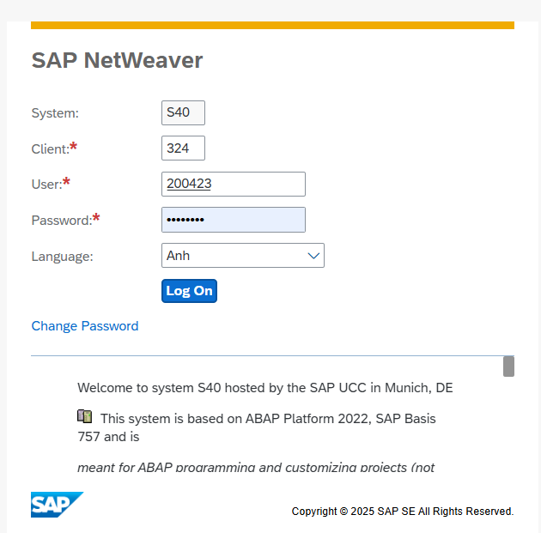

Transaction Code
T-code | Description
ZFIECAP | Display information of advance request

Enter,
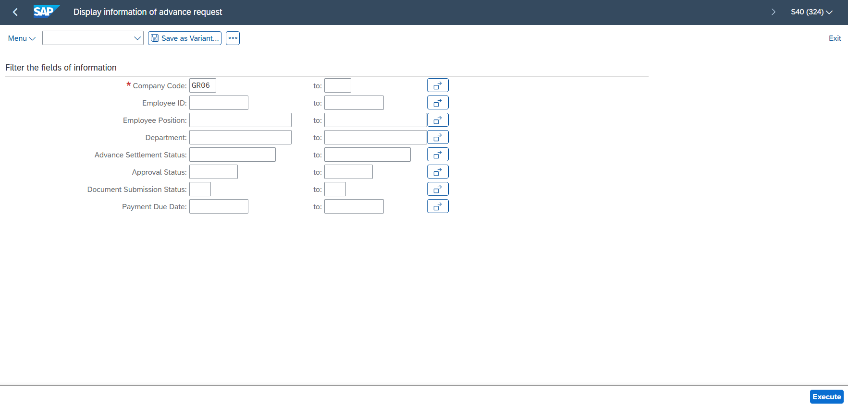
Press ,


Press ”Find”,
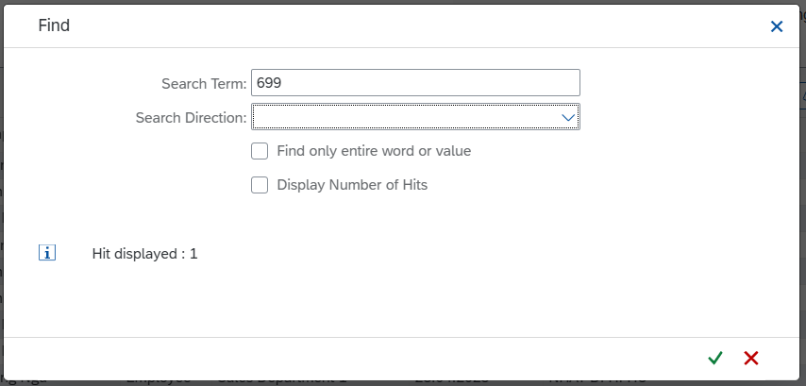

3.9.2.1. Accountant approves the advance request
Select of the row with the request ID that needs approval, then click , to show invoices of this request ID.

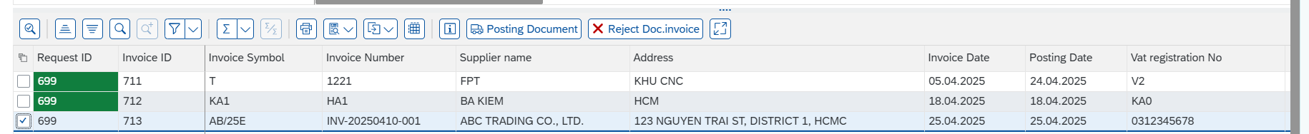
Select of the row with the Invoice ID that needs approval, then click


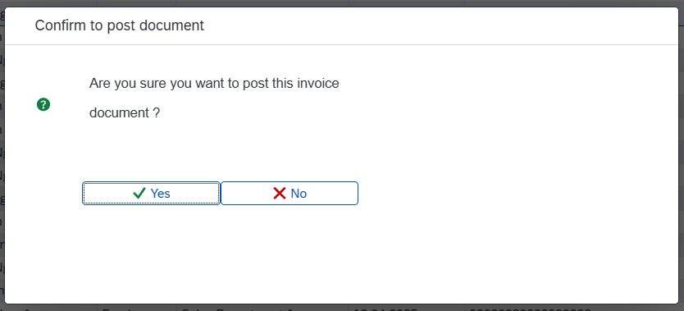
Press ,
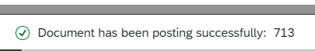
The invoice has been approved.

3.9.2.2. Accountant rejects the advance request
Select of the row with the Invoice ID that needs rejection, then click


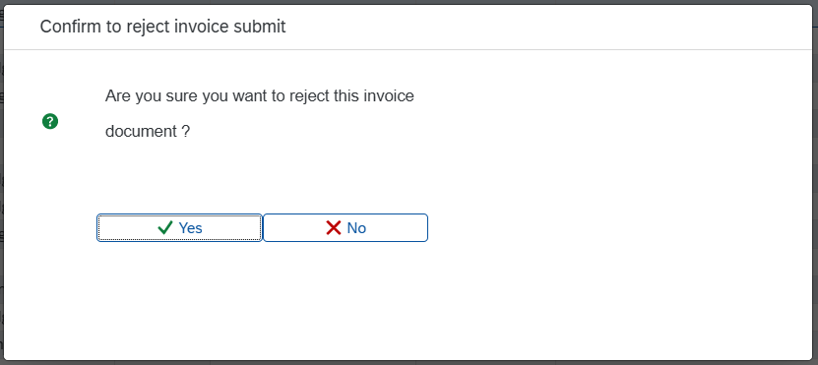
Press ,
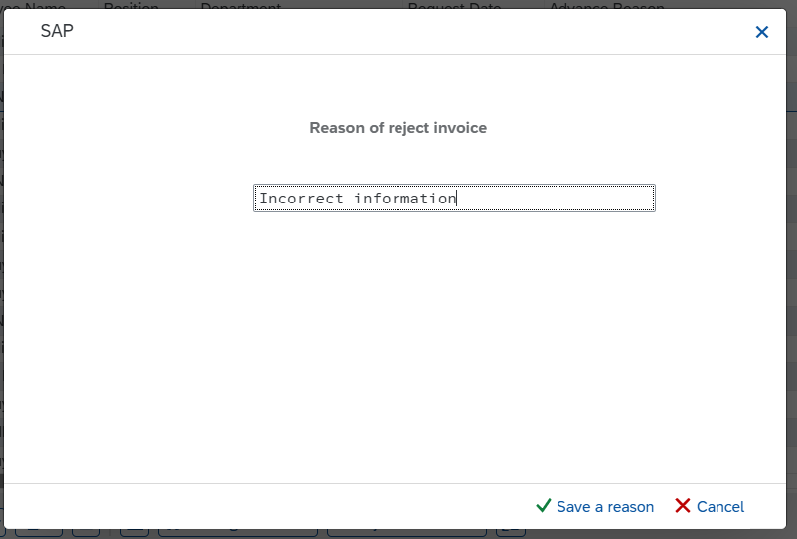

Field name | R/O/D | Description and Example
Reason of reject invoice | R | Ex: Incorrect information

Press ,

The invoice has been rejected.

3.10. Advance settlements

3.10.1. Context
"Advance Settlement" refers to the reconciliation between the paid advance and actual incurred expenses. In ZFIECAP, the user must declare detailed expense items such as airfare, taxi, accommodation, or purchased materials, along with related invoices or receipts. These supporting documents must be clear, valid, and comply with company policies. The accountant will then compare the total actual expenses with the initial advance amount to determine whether the employee must return money to the company or receive an additional payment.

3.10.2. Details Implement

Transaction Code
T-code | Description
ZFIECAP | Display information of advance request

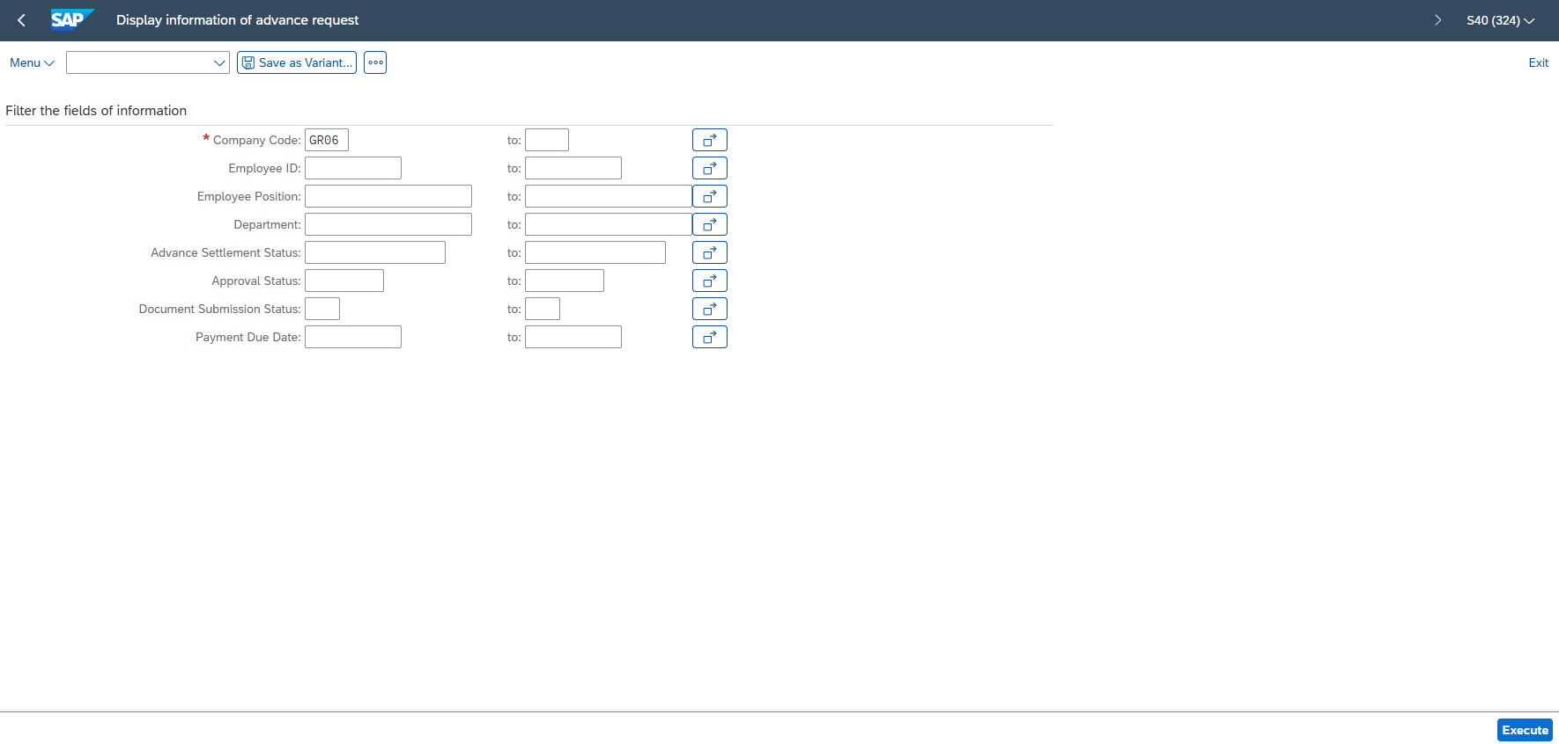
Press Execute
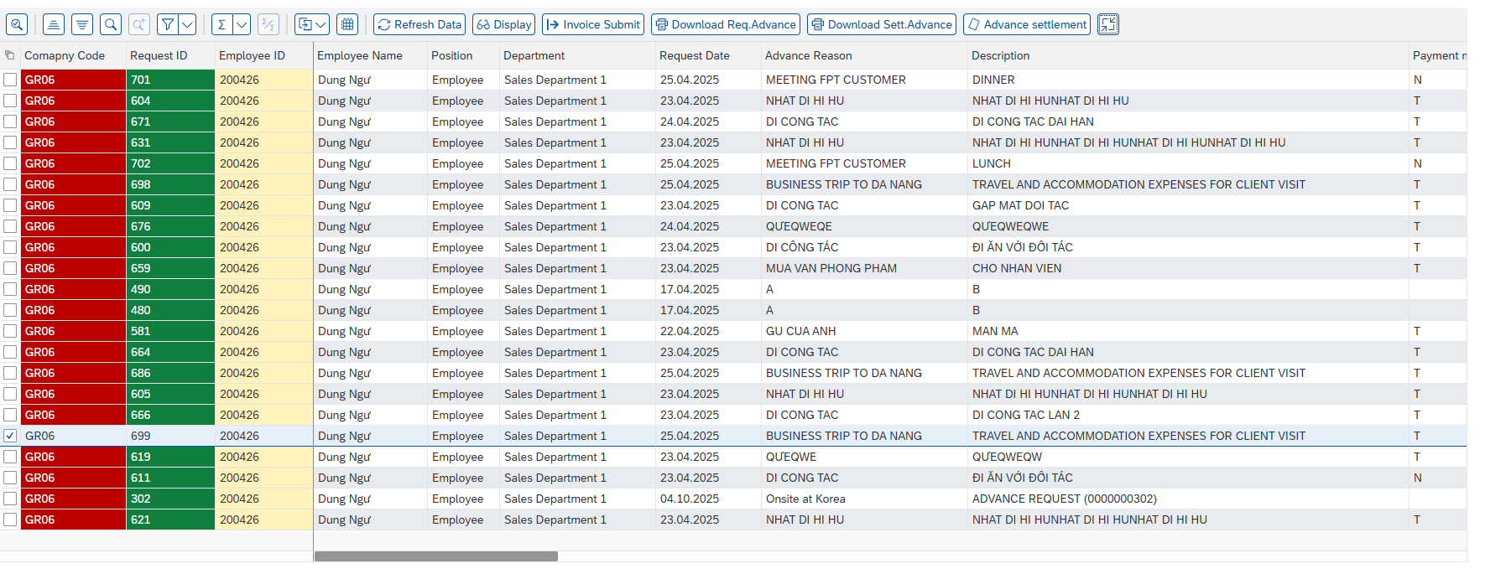
Select of the row with the request ID that needs settle,
then click to clear the advance request that has already been paid, and whose related invoices have been approved.

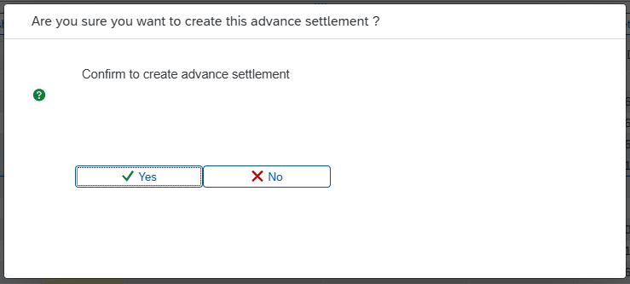
Press ,

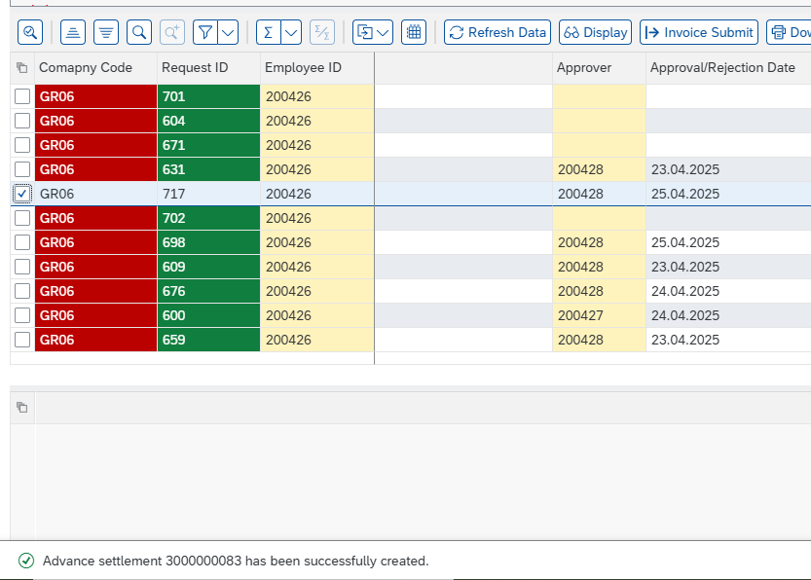
Advance settlement has been successfully created.

3.11. Download form the advance settlement

3.11.1. Context
At this step, users need to download and print both the standard settlement form and the original advance request form from ZFIECAP using the “Download Settlement Advance” function. The printed documents must be attached with the original invoices and supporting documents. After printing, the entire set (including the settlement form, advance request form, and supporting documents) must be signed by the employee, the Director, and the accountant before being submitted to the Finance Department for final settlement processing. The settlement form generated from the SMF system summarizes the actual expenses, the amount to be returned to the company (if underused), or the amount to be reimbursed to the employee (if overused).

3.11.2. Details Implement
Transaction Code
T-code | Description
ZFIECAP | Display information of advance request

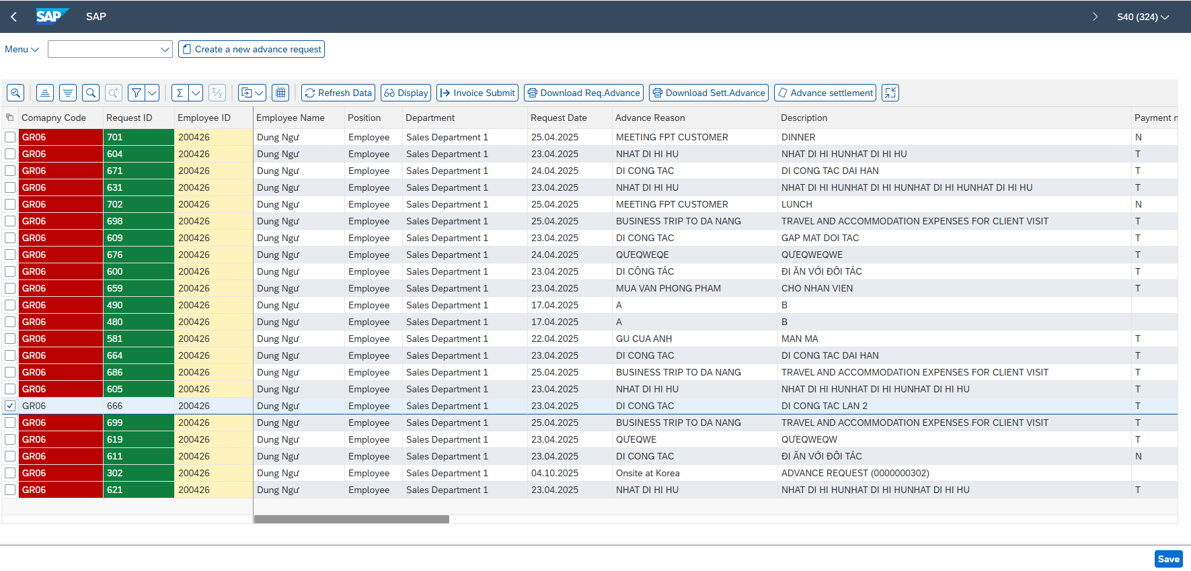
Press , to download the SMF Settlement Advance document

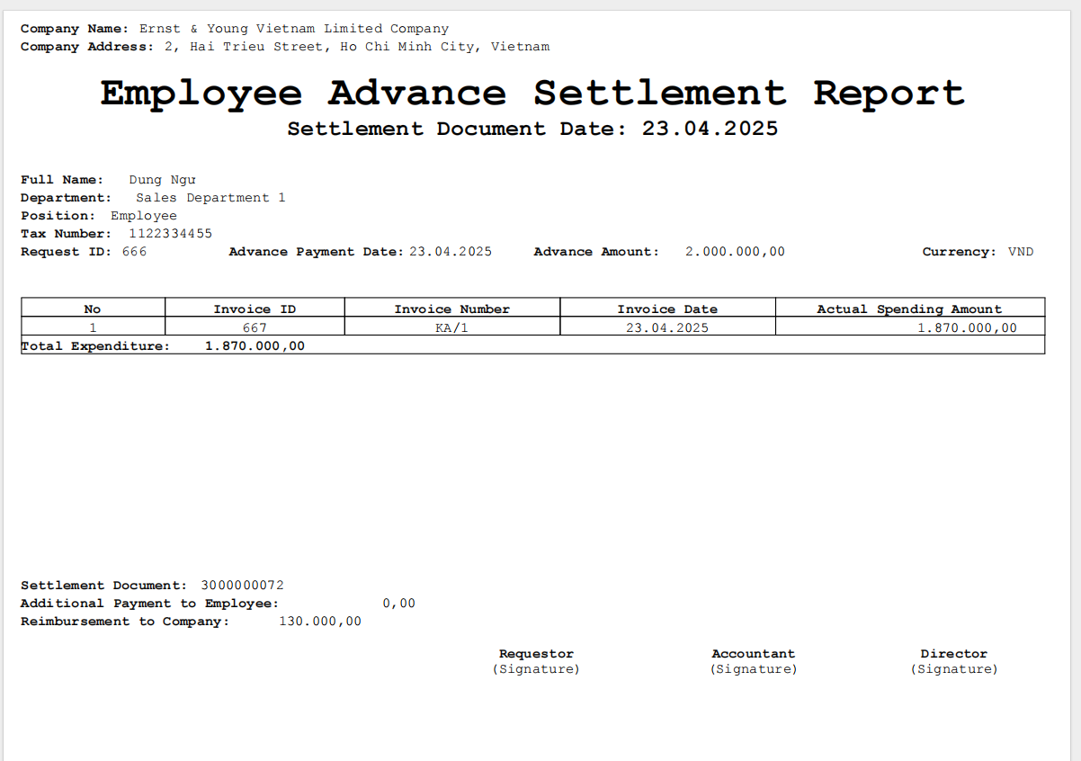

3.12. Post Incoming Payments / Post Outgoing Payments

3.12.1. Context
T-Code F-28 is used to post incoming payments when an employee returns the unused portion of an advance, while Trasaction “T-code: F-53” is used to record outgoing payments when the company reimburses the employee for expenses exceeding the original advance. At this stage, the accountant must carefully input all relevant information, including to the employee's vendor code, bank account details, offsetting accounts, payment method, and the exact transaction amount. Each posting must align with the approved settlement documents to ensure accuracy and completeness. This step finalizes the advance settlement process and ensures the company’s financial records are up to date and accurate.

3.12.2. Details Implement
Transaction Code
T-code | Description
ZFIECAP | Display information of advance request
F-28 / F-53 | Post Incoming Payments / Post Outgoing Payments

Access T-code ZFIECAP to view information about the amounts.
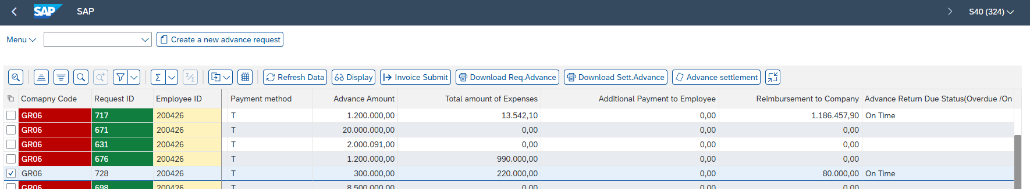

When the field 'Advance Amount' is greater than the field 'Total Amount of Expenses', go to T-code F-28 and enter the necessary information to record the reimbursement to the company.

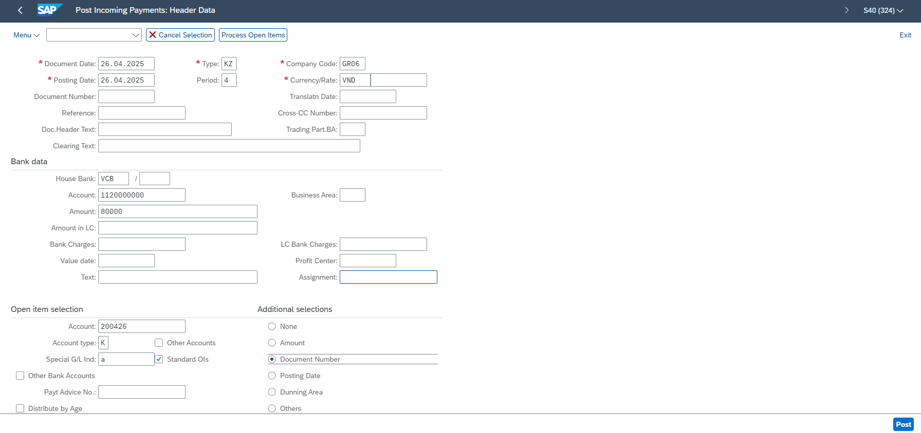

No. | Field name | R/O/D | Description and Example
1 | Document Date | R | 26.04.2025
2 | Posting Date | R | 26.04.2025
3 | Type | R | KZ
4 | Period | R | 4
5 | Company Code | R | GR06
6 | Currency/Rate | R | VND/ “ “
Bank data
1 | House Bank | R | VCB
2 | Account | R | 1120000000
3 | Amount | R | 80000
Open item selection
1 | Account | R | 200426
2 | Account type | R | K
3 | Special G/L Ind | R | a
Additional selections
1 | Document Number | R

Press ,

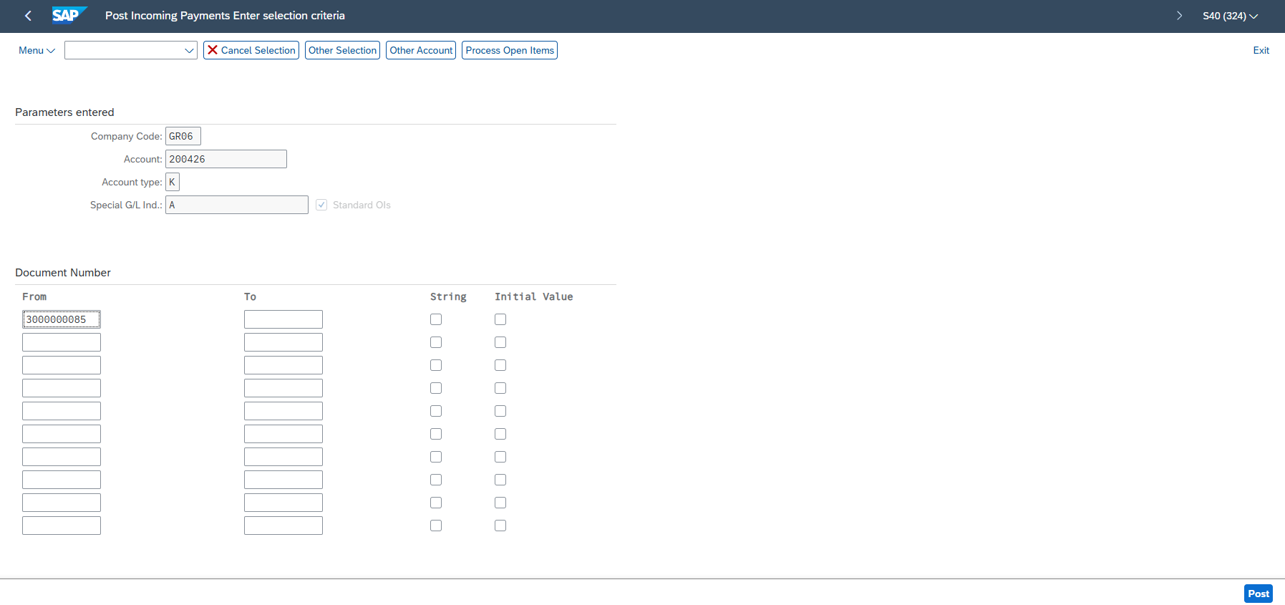

Retrieve the information from the ‘Settlement Document’ field in T-code ZFIECAP to fill in
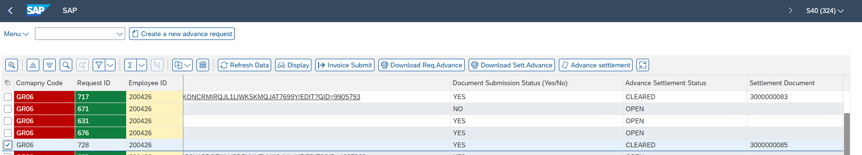

From | To
3000000085

Press , a message appears, and this step is completed.

Perform the Post Outgoing Payments (F-53) similarly to the steps above. When the field 'Total Amount of Expenses' is greater than the field ‘Advance amount’, the company will proceed with posting the outgoing payment and paying the employee. Ex: Request ID - 605
